
CO2 - ASSESSMENT 1
REPORT ANALYSIS
Course Faculty : Dr. K.Anbazhagan
Course Name : Ethical Hacking
Course Code : ITA1406
Slot : Slot B
Total Marks : 100

CO2 :
Foot printing Tools: Conducting Competitive Intelligence, DNS Zone Transfers,
Introduction to Social Engineering: Social Engineering Attacks and Countermeasures. (BT3)

Code of Conduct:
I P Sai Rakesh Reddy (192365060) (Name / Reg No) certify that this submission is my original work and that I have adhered to the guidelines specified for this assessment.
I understand that any violation of academic integrity rules will result in disciplinary action.

Signature of the student: Rakesh

Answer the Following
Kindly follow the below step to do Domain & Email Footprinting using theHarvester
Step 1: Install Python
- Open https://www.python.org/downloads/
- Download the latest Python version.
- Run the installer.
- Tick Add Python to PATH • Click Install Now
Step 2: Verify Python Installation
- Press Windows + R
- Type cmd and press Enter
- Run: [python -m pip install --upgrade pip] in cmd
Step 4: Install theHarvester
- Run: [pip install theHarvester] in cmd
- Run: [python -m pip install theHarvester] in cmd
- Wait until the installation Tinishes.
Step 5: Verify theHarvester
- Run: [theHarvester --help] in cmd
Step 6: Run theHarvester
- Run: [theHarvester -d saveetha.com -b all] in cmd
Step 7: Wait for the Results
- After a few minutes, theHarvester displays information such as:
- Email Addresses
- Subdomains
- Host Names
- IP Addresses
Fill the following required details

Domain Name
Emails found (List all one by one)
Sub emails found (List all one by one)
Hosts and Its IP (List all one by one)
Total Email Addresses Found
Total Subdomains Found
Total Hosts Found
Total IP Addresses Found
Screenshot of Commend execution
Screenshot of theHarvester output
RUBRICS

Criteria | Weightage (%) | Level 4 (Exemplary) | Level 3 (ProYicient) | Level 2 (Developing) | Level 1 (Beginning)
Tool  Installation and  ConYiguration | 25% | Successfully installs, veriTies, and  conTigures  theHarvester and required  environment without errors. | Installs and conTigures the tool correctly with minor issues. | Completes installation with assistance and encounters several conTiguration issues. | Unable to install,  conTigure, or verify the tool.
Footprinting  Data Collection | 25% | Accurately collects and organizes  emails, sub-emails,  hosts, IP addresses, and subdomains comprehensively. | Collects most required  footprinting  information with minor omissions. | Collects limited information or misses several required Tields. | Fails to obtain meaningful  footprinting information.
Analysis and  Interpretation of Results | 30% | Thoroughly analyzes theHarvester output and accurately interprets the  signiTicance of discovered information. | Correctly interprets most  results with minor errors. | Provides basic interpretation with limited technical understanding. | Unable to interpret the collected  footprinting information.
Evidence and  Documentatio  n | 20% | Provides complete screenshots, counts, lists, and organized  documentation with technically accurate presentation. | Provides adequate evidence and  documentation with minor omissions. | Documentation is partially complete or poorly organized. | Evidence is missing,  incomplete, or difTicult to verify.

Domain Name: saveetha.com
Emails found: zero
Sub emails found: zero
Hosts and Its IP:
Host | IP Address
www.saveetha.com | 198.185.159.144
saveetha.com | 3.110.122.44

IP Addresses found:
- 103.249.82.245
- 103.249.82.249
- 106.51.116.185
- 118.139.175.1
- 14.139.187.227
- 14.98.51.2
- 180.235.121.243
- 182.19.38.181
- 198.185.159.144
- 198.185.159.145
- 198.49.23.144
- 198.49.23.145
- 199.34.228.77
- 3.110.122.44
- 34.149.87.45
- 43.204.251.6
- 43.205.1.154

Hosts found:
- 360.saveetha.com
- admission.saveetha.com
- admission.sse.saveetha.com
- admissions.saveetha.com
- anat.sdc.saveetha.com
- api.vbuy.saveetha.com
- arms.libarts.saveetha.com
- arms.scad.saveetha.com
- arms.scahs.saveetha.com
- arms.scon.saveetha.com
- arms.scop.saveetha.com
- arms.scpt.saveetha.com
- arms.sdc.saveetha.com
- arms.shost.saveetha.com
- arms.sibms.saveetha.com
- arms.smc.saveetha.com
- arms.soct.saveetha.com
- arms.sse.saveetha.com
- arms.ssl.saveetha.com
- arms.ssm.saveetha.com
- arms.sspe.saveetha.com
- biochem.sdc.saveetha.com
- brulac.sdc.saveetha.com
- civil.sse.saveetha.com
- cse.sse.saveetha.com
- dias.sdc.saveetha.com
- diasfiles.saveetha.com
- elearning.dental.saveetha.com
- empowher.saveetha.com
- endo.sdc.saveetha.com
- epay.saveetha.com
- esthetics.sdc.saveetha.com
- food.saveetha.com
- gpath.sdc.saveetha.com
- hostel.saveetha.com
- implant.sdc.saveetha.com
- isss.saveetha.com
- libarts.saveetha.com
- life.saveetha.com
- lms.sse.saveetha.com
- mail.saveetha.com
- mias.files.smc.saveetha.com
- mias.smc.saveetha.com
- micro.sdc.saveetha.com
- naac.saveetha.com
- nmc.mias.smc.saveetha.com
- omed.sdc.saveetha.com
- omfs.sdc.saveetha.com
- online.saveetha.com
- opath.sdc.saveetha.com
- oralcancerinstitute.sdc.saveetha.com
- ortho.sdc.saveetha.com
- pacs.saveetha.com
- pacs.vhealth.saveetha.com
- pedo.sdc.saveetha.com
- perio.sdc.saveetha.com
- pharm.sdc.saveetha.com
- phd.sdc.saveetha.com
- physio.sdc.saveetha.com
- portal.saveetha.com
- prime.sdc.saveetha.com
- prostho.sdc.saveetha.com
- said.sdc.saveetha.com
- scad.saveetha.com
- scahs.saveetha.com
- scet.saveetha.com
- scon.saveetha.com
- scot.saveetha.com
- scp.saveetha.com
- scpt.saveetha.com
- sdc.saveetha.com
- sdg.saveetha.com
- simatsadmissions.saveetha.com
- simatsentrance.saveetha.com
- simatsexam.saveetha.com
- simatslab.saveetha.com
- simatstransport.saveetha.com
- smartcard.saveetha.com
- smc.saveetha.com
- sse.saveetha.com
- ssl.saveetha.com
- ssm.saveetha.com
- sspe.saveetha.com
- thepupil.saveetha.com
- vbuy.saveetha.com
- vconnect.saveetha.com
- vhealth.saveetha.com
- vquest.saveetha.com
- vstay.saveetha.com
- vstudy.saveetha.com
- vtrip.saveetha.com
- webmail.saveetha.com
- whitelab.sdc.saveetha.com
- www.arms.shost.saveetha.com
- www.arms.sibms.saveetha.com
- www.arms.sse.saveetha.com
- www.brulac.sdc.saveetha.com
- www.endo.sdc.saveetha.com
- www.esthetics.sdc.saveetha.com
- www.gpath.sdc.saveetha.com
- www.implant.sdc.saveetha.com
- www.isss.saveetha.com
- www.lms.smc.saveetha.com
- www.mias.files.smc.saveetha.com
- www.mias.smc.saveetha.com
- www.naac.saveetha.com
- www.nmc.mias.smc.saveetha.com
- www.omed.sdc.saveetha.com
- www.oralcancerinstitute.sdc.saveetha.com
- www.phd.sdc.saveetha.com
- www.physio.sdc.saveetha.com
- www.portal.saveetha.com
- www.said.sdc.saveetha.com
- www.saveetha.com
- www.scad.saveetha.com
- www.scahs.saveetha.com
- www.scon.saveetha.com
- www.scot.saveetha.com
- www.scp.saveetha.com
- www.scpt.saveetha.com
- www.sdc.saveetha.com
- www.simatstransport.saveetha.com
- www.smc.saveetha.com
- www.sse.saveetha.com
- www.ssl.saveetha.com
- www.ssm.saveetha.com
- www.sspe.saveetha.com
- www.vstudy.saveetha.com
- www.whitelab.sdc.saveetha.com

Total Email Addresses Found: zero
Total Subdomains Found: 129
Total Hosts found: 129
Total IP Addresses Found: 23
Screenshot of Commend execution:
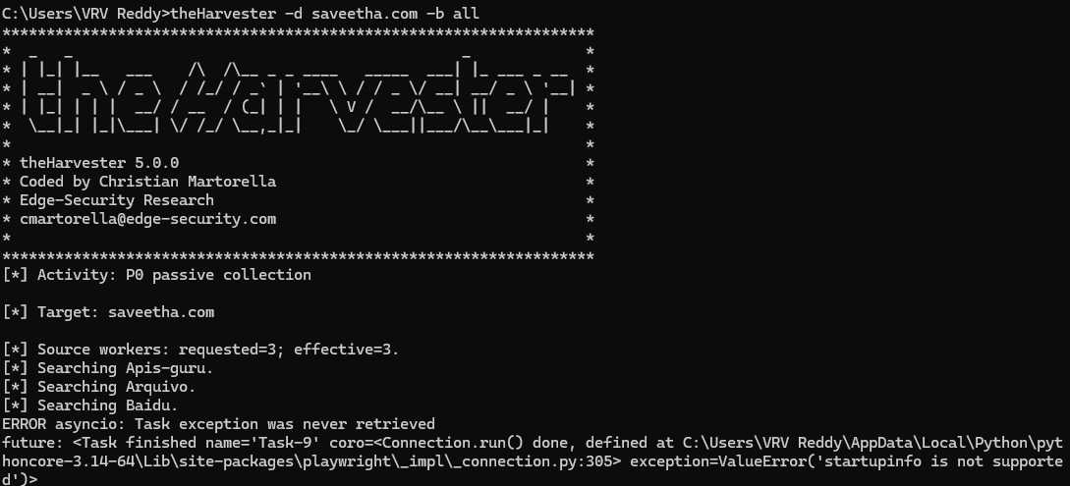

Screenshot of theHarvester output:
